**Week07 Assignment Due Oct 16 (25 points total)**

Tests on one or two groups of independent data – part assignment, part tutorial

Q1(a-e). Looking at Figure 1k of the Silvestre-Roig paper (**the violin plot from the Week03 assignment**), the authors measured the distance of macrophages and SMCs to proximal neutrophils. It is your task to perform **the least biased statistical test** to help you determine if there is a difference in distance between macrophages and SMCs.

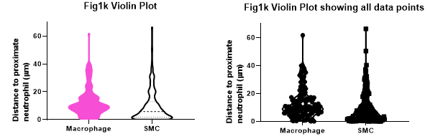

The data are clearly continuous and we have two groups (macrophages, SMCs). Let’s examine if the data meet the assumptions for **an unpaired (AKA independent, two-sample) t-test**.

***Assumption of independence***. If you look at the data in the excel file, each measurement was done in a single neutrophil numbered 1 -117. I tried to determine if each neutrophil independent from all other neutrophils (i.e., from separate samples or mice) or were they all measured in a single sample or animal. I tried reading the paper to see what they did, but I could not figure it out (I am not an expert in the topic). For this exercise, we will assume all neutrophils are independent. Also, are the SMC and macrophage measurements in each neutrophil independent or is there some correlation between the two? Again, I cannot figure out the biology so we will assume the two measurements are independent. If both cases of independence are true, **the data meet the assumption of independence for an unpaired t-test**. The authors stated they did an unpaired t-test so I guess they considered the data to be independent (if they worried about it…).

***Assumption of normality*.** Looking at the descriptive data you filled out for Q1a of the Week03 assignment and at the figures you plotted, the data have **strong right skew** so they fail the assumption of normality.

***Assumption of homoscedasticity***. Looking at the descriptive data you filled out for Q1a of the Week03 assignment, you can see that **the SD for both groups are very similar** and **the ratio of the two groups is <2**. We conclude the data meet the assumption of homoscedasticity.

Q1a. Despite the fact that the raw (not transformed) data failed the normality assumption, do you think you can still **use an unpaired t-test** on the raw data? List your evidence both pro and con, at least list one pro and one con (2 pts)

Yes or No, and at least list one pro and one con.

Sample size is large (>30), and the samples are independent PRO

Data are skewed (CON), but the skew is in the same direction (PRO).

But there are difference n’s in each group (unbalanced design; CON)

t-tests are robust to some deviations from normality and homoscedasticity

For the purposes of this exercise, we will do both parametric and non-parametric tests on the data.

Q1b. State the null and a two-sided alternative hypothesis for an unpaired t-test (describe it in statistical context, aka parameters or estimators). (1 pt)

Bonus point: What if it is one-sided unpaired t-test?

Null: the means are equal

Alternative: the means are not equal

Q1c. Perform an unpaired t-test (**both equal and unequal variances** – **Welch’s t-test**) and **a Mann-Whitney test** on the data and complete the table below. Make sure you set it up to subtract the SMC from the macrophage values in Prism. I did an analysis on LN(Y+1) transformed data. The transformation worked to create a more symmetrical distribution. (2.5 pts)

t-test, **equal** t-test, t-test, LN+1 Mann-Whitney

variances **unequal**  transformed

t-statistic __________ _________ 4.58 NA

degrees of freedom __________ _________ 317 NA

p-value __________ 0.006 <0.0001 ___________

95% CI __________ _________ 0.28 to 0.71 Don’t calculate

Difference __________ _________ 0.49 ___________ (actual)

t-test, equal t-test t-test, LN+1 Mann-Whitney

variances unequal transformed

t-statistic 2.75 2.76 4.58 NA

degrees of freedom 317 313.9 317 NA

p-value 0.006 0.006 <0.0001 <0.0001

95% CI (2 decimals) 0.94 to 5.67 0.95 to 5.66 0.28 to 0.71 Don’t calculate

Difference 3.31 3.31 0.49 4.11 (Actual)

Notice that the p-value for **the transformed data and the Mann-Whitney** are the same and **smaller than** that of **the t-test** on the raw data. This might indicate that a t-test on the raw data may not be the least biased test (despite being robust to violations of test assumptions). The violation of normality assumption does affect the results of t-test. The skewness of the data could not be ignored in other case.

Although you come to the same conclusions about the null hypothesis no matter which test you use, the test on **the transformed data or the non-parametric Mann-Whitney might be the better way** to test the difference between the two groups. The skew in the data may have been too large to ignore despite the larger sample size.

Q1d. Write up the results for the Mann-Whitney test, (please include what is your test and sample size, what is your null hypothesis, whether you reject it, and your p-value with reasons). (2 pts)

The data for both groups failed the assumption of normality for an independent t-test

so we performed the non-parametric Mann Whitney U test.

With p<0.0001 (two-sided Mann-Whitney test, =0.05), we reject the null hypothesis of no difference in rank score distribution of distance to proximal neutriphils between macrophage and SMCs.

We conclude that macrophages have longer distances (median = 9.87) compared to SMCs (5.75).

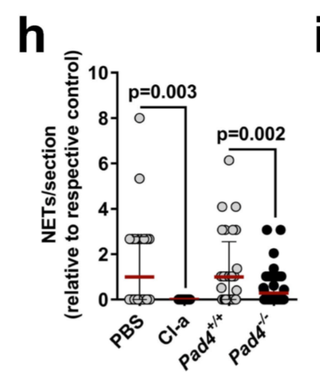

Q2a. In Extended figure 4h above from the Silvestre-Roig paper, the authors reports an unpaired t-test p=0.03 for the comparison between PBS and Cl-a. Does their t-test result assume **equal or unequal variances** **(run both tests yourself to see)**? Include **the p-values for both t-tests** with your answer. (1 pt)

Equal p=0.0026, unequal p=0.001. They reported a t-test assuming equal variances.

Q2b. If you look at the figure and the data, all values for Cl-a are zero. It might be better to do a one-sample test that compares the PBS data to zero. Perform **both a one-sample t-test and a Wilcoxon signed rank test** and fill out the table below. (1.5 pts)

One-sample t-test Wilcoxon signed rank

t-statistic _______________ NA

df 39 NA

p-value _______________ _________________

95%CI _______________ NA

Difference _______________ _________________

One-sample t-test Wilcoxon signed rank

t-statistic 3.553 NA

df 39 NA

p-value 0.001 0.0005

95%CI 0.43 to 1.57 NA

Difference 1 0

Q3c. Which one sample test do you think is better and why? (2 pts)

The Wilcoxon signed rank test because the data violate the assumption of normality

For the remaining questions we will use data from the following paper:

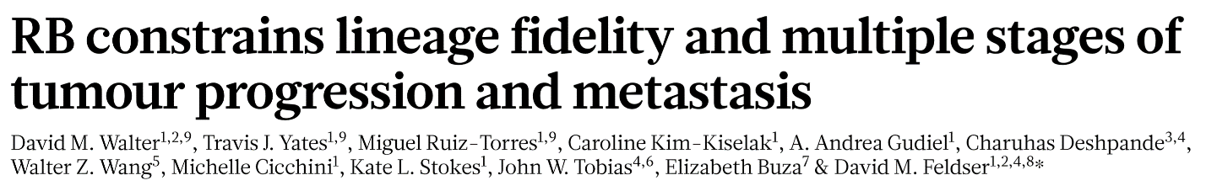

Nature 569 , 423–427 (2019)

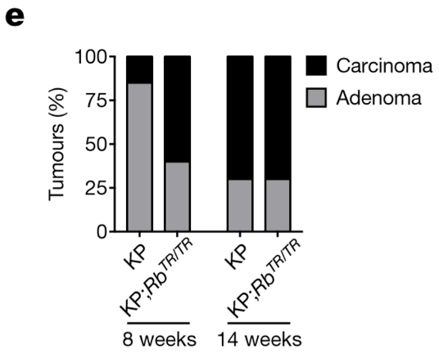

Q3a. Looking at Fig 1e above and its data from the Walter paper, are the data **categorical** or **continuous**? (1 pt)

categorical

Q3b. State the null and alternative hypotheses for a two-sided test for the data in the 8 week group. Answer the question in statistical context (1 pt)

Null: The proportions of carcinoma will be the same between the KP and the KP-Rb groups

Alternative: The proportions will be the same

Q3c. Using data from Walter Fig 1e calculate **chi-square** and **Fisher’s exact tests** for the differences in distribution of carcinoma by KP status for both 8 weeks and 14 weeks. Complete the table below. (2 pts)

8 weeks 14 weeks

KP KPRb KP KPRb

Carcinoma, n (%) 6 (16.2%) _________ _________ ________

Chi-square statistic _________ _________

Chi-square DF _________ 1

Chi-Square p-value _________ 0.88

Fisher’s exact p-value <0.0001 _________

8 weeks 14 weeks

KP KPRb KP KPRb

Carcinoma, n (%) 6 (16.2%) 34 (60.7%) 51 (70.8%) 110 (69.6%)

Chi-square statistic 18.00 0.035

Chi-square DF 1 1

Chi-Square p-value <0.0001 0.88

Fisher’s exact p-value <0.0001 0.89

Q3d. Write up the results for the 14 week Chi-square test results. To get the total points, you need to report the hypothesis, the test you used and the assumption for that test, what is the result from the test, and what is the conclusion. (2 pts)

The data met the chi-square test assumption of independence and no cells had expected values less than 5. With a p=0.88 (two-sided test, chi-square=0.035, 1 df, =0.05), we fail to reject the null hypothesis of no difference in proportions and conclude there is no difference in the proportion of carcinoma in the KP group (70.8%) compared to the KPRb group (69.6%).

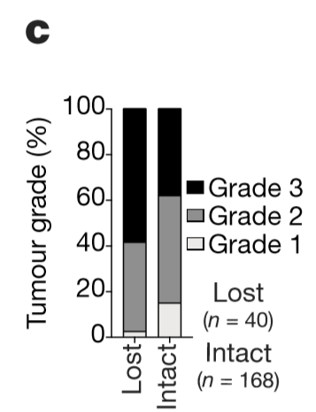

Q4a. We will use the data from figure 3c to perform **a Chi-square test** of trend. The data are appropriate to test an increase or decrease in **proportion of Lost by increasing grade**. There is a natural, meaningful order with increasing cancer grade. State the null and alternative hypothesis for this test in statistical context. (1 pt)

Null: There is no trend in the data (i.e., the proportion of Lost does not increase or decrease with increasing grade

Alternative: There is a trend.

Q4b. The cell for Lost/Grade 1 only has a single value. Fill the table and calculate **the expected value** to see if it is >5. Write the value below. Show your work. (1 pt)

|  |  |  |  |  |
| --- | --- | --- | --- | --- |
|  | **Grade 1** | **Grade 2** | **Grade 3** | **Total** |
| RB pathway lost | 1 | 16 | 24 | 41 |
| RB pathway intact | 25 | 79 | 64 | 168 |
| Total | 26 | 95 | 88 | 209 |

= (41*26)/209 =5.1

Even if you found that the expected value is <5, it is still OK to use the chi-square test because with 6 cells, one cell represents 17% of the cells which is less than 20%.

Q4c. Do **a test of trend** and write up the test your used and the assumptions for this test, your hypothesis, your statistical results and conclusion including a **table**. (3 pts)

We decided to do a Chi-square test for trend of the data.

We met the test assumptions: the counts are independent, the order of the trend is logical, and the intervals are equal across the group.

With p=0.005 (chi- square=7.79, df=1, =0.05), we reject the null hypothesis of no trend and conclude that the percentage of Lost Rb pathway increases with increasing grade (see table below).

Rb Pathway Lost n (%)

Grade 1 1 (3.8%)

Grade 2 16 (16.8%)

Grade 3 24 (27.3%)

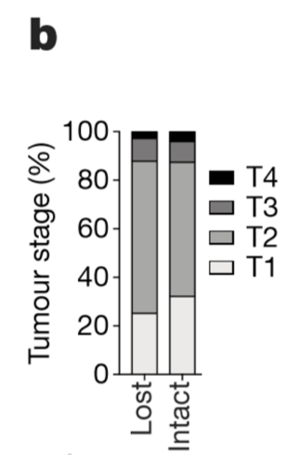

Q5. Now you will do **a chi-square goodness of fit test** on the data in Figure 3b of the Walter paper. Compare the Lost group proportions to the Intact as the expected distribution. Assume the test meets all assumptions. Write up the results. **No need to include a table**. (2 pts) To get the whole points, you need to answer what is the hypothesis, what test you use and why, and what is your results and conclusion.

We tested the hypothesis that the distribution of tumor stages for RB pathway lost is the same as the distribution for the intact pathway.

We met the assumptions of a Chi-square goodness of fit test (independent observations, expected cell frequencies >5).

With p=0.36, we fail to reject the null hypothesis that the data are consistent with the intact distribution and conclude that our data are not different from what is expected.